CSA-0918
M. VIKAS CHOWDARY
192324310
1)
Most HackerRank challenges require you to read input from stdin (standard input) and write output to stdout (standard output).
One popular way to read input from stdin is by using the Scanner class and specifying the Input Stream as System.in. For example:
Scanner scanner = new Scanner(System.in);
String myString = scanner.next();
int myInt = scanner.nextInt();
scanner.close();

System.out.println("myString is: " + myString);
System.out.println("myInt is: " + myInt);
The code above creates a Scanner object named and uses it to read a String and an int. It then closes the Scanner object because there is no more input to read, and prints to stdout using System.out.println(String). So, if our input is:
Hi 5
Our code will print:
myString is: Hi
myInt is: 5
Alternatively, you can use the BufferedReader class.
Task
In this challenge, you must read integers from stdin and then print them to stdout. Each integer must be printed on a new line. To make the problem a little easier, a portion of the code is provided for you in the editor below.
Input Format
There are lines of input, and each line contains a single integer.
Sample Input
42
100
125
Sample Output
42
100
125
Language
Java 15
More
1
2
3
4
5
6
7
8
9
10
11
12
13
14
15
16
Line: 16 Col: 1
Test against custom input

CODE:
import java.util.Scanner;

public class Solution {
public static void main(String[] args) {
Scanner scanner = new Scanner(System.in);
int a = scanner.nextInt();
int b = scanner.nextInt();
int c = scanner.nextInt();
scanner.close();

System.out.println(a);
System.out.println(b);
System.out.println(c);
}
}

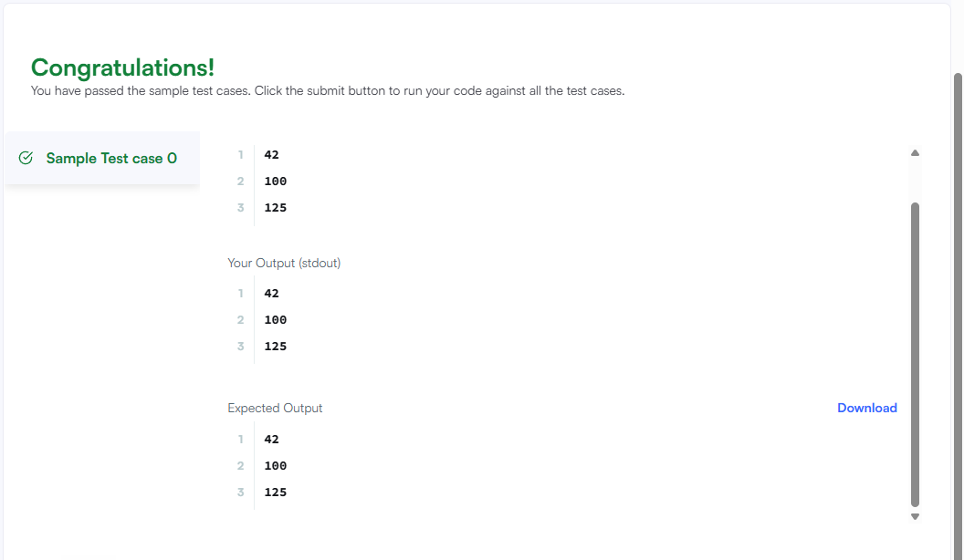

2
In this challenge, we test your knowledge of using if-else conditional statements to automate decision-making processes. An if-else statement has the following logical flow:
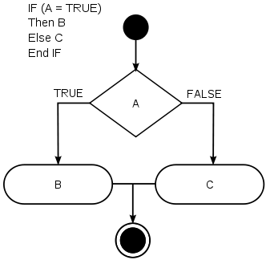
_{Source:} Wikipedia
Task
Given an integer, , perform the following conditional actions:
- If is odd, print Weird
- If is even and in the inclusive range of to , print Not Weird
- If is even and in the inclusive range of to , print Weird
- If is even and greater than , print Not Weird
Complete the stub code provided in your editor to print whether or not is weird.
Input Format
A single line containing a positive integer, .
Constraints

Output Format
Print Weird if the number is weird; otherwise, print Not Weird.
Sample Input 0
3
Sample Output 0
Weird
Sample Input 1
24
Sample Output 1
Not Weird
Explanation
Sample Case 0:
is odd and odd numbers are weird, so we print Weird.
Sample Case 1:
and is even, so it isn't weird. Thus, we print Not Weird.
Language
Java 15
More
1
2
3
4
5
6
7
8
9
10
11
12
13
14
15
16
17
18
19
20
21
22
23
Line: 23 Col: 1
Test against custom input

CODE:
import java.util.Scanner;

public class Solution {
public static void main(String[] args) {
Scanner sc = new Scanner(System.in);
int n = sc.nextInt();

if (n % 2 != 0) {

System.out.println("Weird");
} else {

if (n >= 2 && n <= 5) {
System.out.println("Not Weird");
} else if (n >= 6 && n <= 20) {
System.out.println("Weird");
} else {
System.out.println("Not Weird");
}
}
}
}

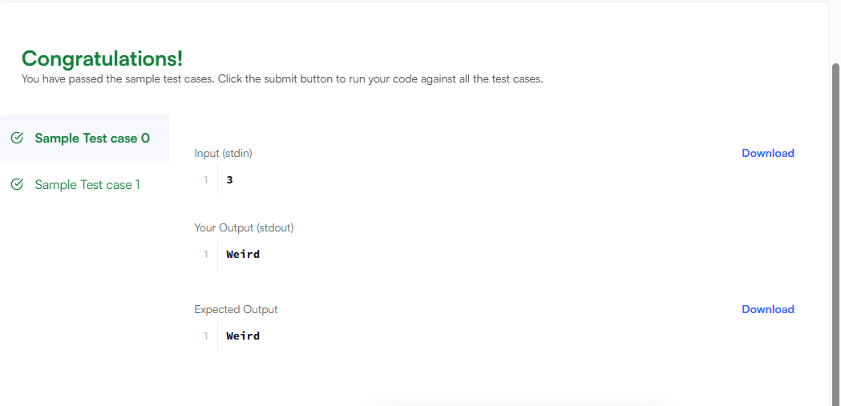
3
In this challenge, you must read an integer, a double, and a String from stdin, then print the values according to the instructions in the Output Format section below. To make the problem a little easier, a portion of the code is provided for you in the editor.
Note: We recommend completing Java Stdin and Stdout I before attempting this challenge.
Input Format
There are three lines of input:
- The first line contains an integer.
- The second line contains a double.
- The third line contains a String.
Output Format
There are three lines of output:
- On the first line, print String: followed by the unaltered String read from stdin.
- On the second line, print Double: followed by the unaltered double read from stdin.
- On the third line, print Int: followed by the unaltered integer read from stdin.
To make the problem easier, a portion of the code is already provided in the editor.
Note: If you use the nextLine() method immediately following the nextInt() method, recall that nextInt() reads integer tokens; because of this, the last newline character for that line of integer input is still queued in the input buffer and the next nextLine() will be reading the remainder of the integer line (which is empty).
Sample Input
42
3.1415
Welcome to HackerRank's Java tutorials!
Sample Output
String: Welcome to HackerRank's Java tutorials!
Double: 3.1415
Int: 42
Language
Java 15
More
1
2
3
4
5
6
7
8
9
10
11
12
13
14
15
16
Line: 16 Col: 1
Test against custom input
CODE:
import java.util.Scanner;

public class Solution {
public static void main(String[] args) {
Scanner scan = new Scanner(System.in);
int i = scan.nextInt();
double d = scan.nextDouble();
scan.nextLine();
String s = scan.nextLine();

System.out.println("String: " + s);
System.out.println("Double: " + d);
System.out.println("Int: " + i);
}
}

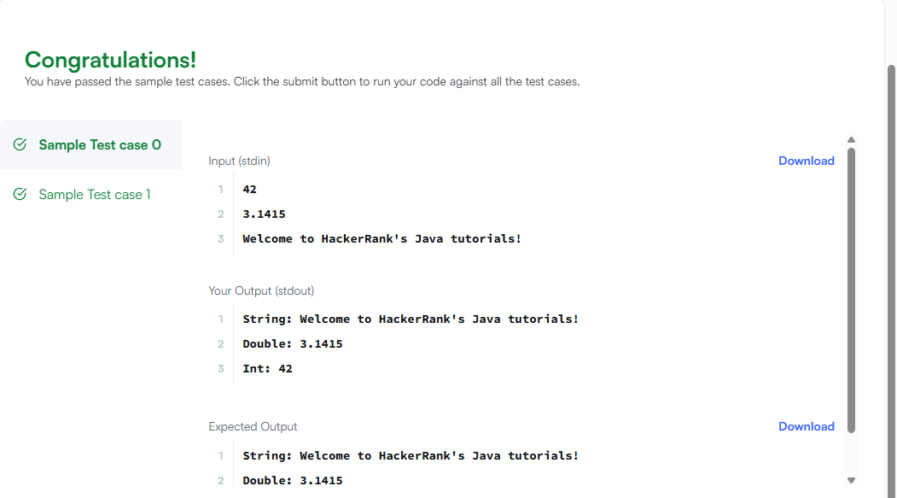
4

Objective
In this challenge, we're going to use loops to help us do some simple math.
Task
Given an integer, , print its first multiples. Each multiple (where ) should be printed on a new line in the form: N x i = result.
Input Format
A single integer, .
Constraints

Output Format
Print lines of output; each line (where ) contains the of in the form:
N x i = result.
Sample Input
2
Sample Output
2 x 1 = 2
2 x 2 = 4
2 x 3 = 6
2 x 4 = 8
2 x 5 = 10
2 x 6 = 12
2 x 7 = 14
2 x 8 = 16
2 x 9 = 18
2 x 10 = 20
Language
Java 15
More
1
2
3
4
5
6
7
8
9
Line: 9 Col: 1
Test against custom input
CODE:
import java.util.*;
public class Solution {
public static void main(String[] args) {
int n = new Scanner(System.in).nextInt();
for(int i = 1; i <= 10; i++)
System.out.println(n + " x " + i + " = " + (n*i));
}
}

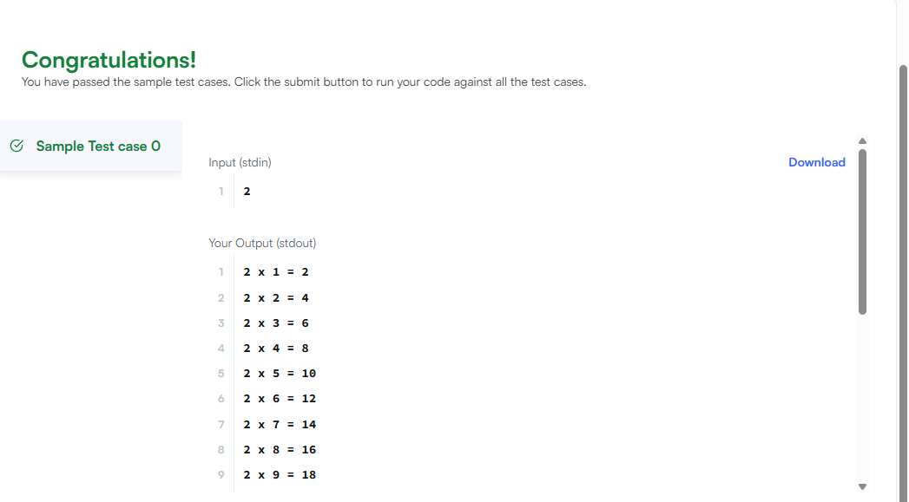
5)
Java has 8 primitive data types; char, boolean, byte, short, int, long, float, and double. For this exercise, we'll work with the primitives used to hold integer values (byte, short, int, and long):
- A byte is an 8-bit signed integer.
- A short is a 16-bit signed integer.
- An int is a 32-bit signed integer.
- A long is a 64-bit signed integer.
Given an input integer, you must determine which primitive data types are capable of properly storing that input.
To get you started, a portion of the solution is provided for you in the editor.
Reference: https://docs.oracle.com/javase/tutorial/java/nutsandbolts/datatypes.html
Input Format
The first line contains an integer, , denoting the number of test cases.
Each test case, , is comprised of a single line with an integer, , which can be arbitrarily large or small.
Output Format
For each input variable and appropriate primitive , you must determine if the given primitives are capable of storing it. If yes, then print:
n can be fitted in:
* dataType
If there is more than one appropriate data type, print each one on its own line and order them by size (i.e.: ).
If the number cannot be stored in one of the four aforementioned primitives, print the line:
n can't be fitted anywhere.
Sample Input
6)
-150
150000
1500000000
213333333333333333333333333333333333
-100000000000000
Sample Output
-150 can be fitted in:
* short
* int
* long
150000 can be fitted in:
* int
* long
1500000000 can be fitted in:
* int
* long
213333333333333333333333333333333333 can't be fitted anywhere.
-100000000000000 can be fitted in:
* long
Explanation
can be stored in a short, an int, or a long.
is very large and is outside of the allowable range of values for the primitive data types discussed in this problem
CODE:
import java.util.*;
import java.math.BigInteger;

public class Solution {
public static void main(String[] args) {
Scanner sc = new Scanner(System.in);
int t = sc.nextInt();
while (t-- > 0) {
BigInteger n = sc.nextBigInteger();
boolean found = false;
StringBuilder sb = new StringBuilder();

if (n.bitLength() < 8) { sb.append("* byte\n"); found = true; }
if (n.bitLength() < 16) { sb.append("* short\n"); found = true; }
if (n.bitLength() < 32) { sb.append("* int\n"); found = true; }
if (n.bitLength() < 64) { sb.append("* long\n"); found = true; }

if (!found) {
System.out.println(n + " can't be fitted anywhere.");
} else {
System.out.println(n + " can be fitted in:");
System.out.print(sb);
}
}
}
}

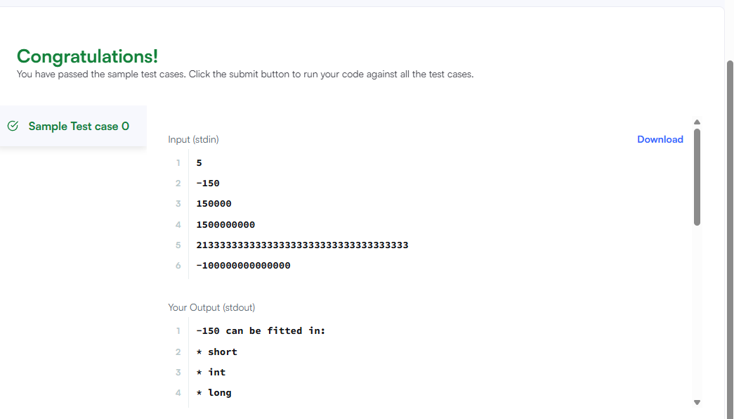

7)
"In computing, End Of File (commonly abbreviated EOF) is a condition in a computer operating system where no more data can be read from a data source." — (Wikipedia: End-of-file)
The challenge here is to read lines of input until you reach EOF, then number and print all lines of content.
Hint: Java's Scanner.hasNext() method is helpful for this problem.
Input Format
Read some unknown lines of input from stdin(System.in) until you reach EOF; each line of input contains a non-empty String.
Output Format
For each line, print the line number, followed by a single space, and then the line content received as input.
Sample Input
Hello world
I am a file
Read me until end-of-file.
Sample Output
1 Hello world
2 I am a file
3 Read me until end-of-file.

CODE:
import java.util.Scanner;

public class Solution {
public static void main(String[] args) {
Scanner scanner = new Scanner(System.in);
int lineNumber = 1;

while (scanner.hasNextLine()) {
String line = scanner.nextLine();
System.out.println(lineNumber + " " + line);
lineNumber++;
}

scanner.close();
}
}

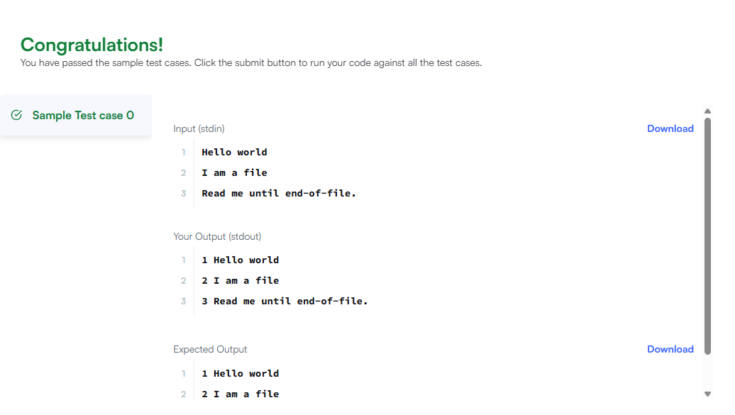

8
Static initialization blocks are executed when the class is loaded, and you can initialize static variables in those blocks.
It's time to test your knowledge of Static initialization blocks. You can read about it here.
You are given a class Solution with a main method. Complete the given code so that it outputs the area of a parallelogram with breadth and height . You should read the variables from the standard input.
If or , the output should be "java.lang.Exception: Breadth and height must be positive" without quotes.
Input Format
There are two lines of input. The first line contains : the breadth of the parallelogram. The next line contains : the height of the parallelogram.
Constraints

Output Format
If both values are greater than zero, then the main method must output the area of the parallelogram. Otherwise, print "java.lang.Exception: Breadth and height must be positive" without quotes.
Sample input 1
1
3
Sample output 1
3
Sample input 2
-1
2
Sample output 2
java.lang.Exception: Breadth and hei
CODE:
import java.util.Scanner;

public class Solution {
static int B, H;
static boolean flag;

static {
Scanner sc = new Scanner(System.in);
B = sc.nextInt();
H = sc.nextInt();

if (B <= 0 || H <= 0) {
flag = false;
System.out.println("java.lang.Exception: Breadth and height must be positive");
} else {
flag = true;
}
}

public static void main(String[] args) {
if (flag) {
System.out.println(B * H);
}
}
}

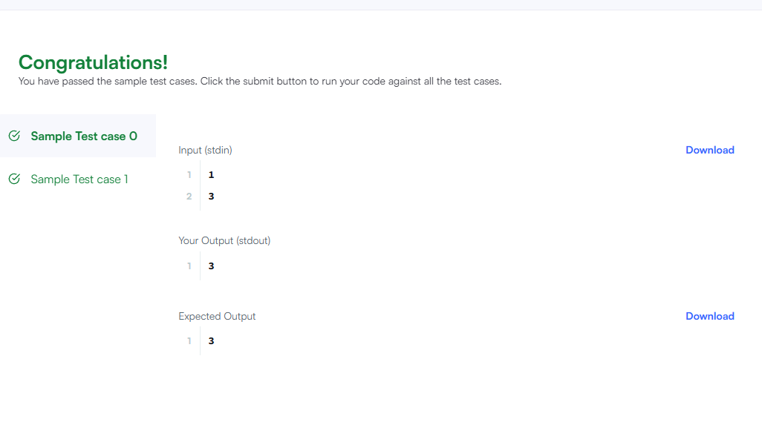

9
You are given an integer , you have to convert it into a string.
Please complete the partially completed code in the editor. If your code successfully converts into a string the code will print "Good job". Otherwise it will print "Wrong answer".
can range between to inclusive.
Sample Input 0
100
Sample Output 0
Good job
CODE:
import java.io.*;
import java.util.*;

public class Solution {

public static void main(String[] args) {
Scanner sc = new Scanner(System.in);
int n = sc.nextInt();

// Convert int to String
String s = String.valueOf(n);

if (s.equals(String.valueOf(n))) {
System.out.println("Good job");
} else {
System.out.println("Wrong answer");
}
}
}

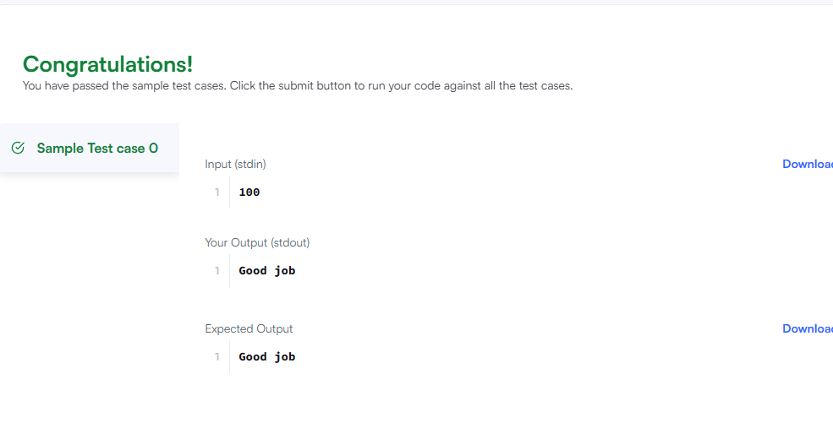

10
The Calendar class is an abstract class that provides methods for converting between a specific instant in time and a set of calendar fields such as YEAR, MONTH, DAY_OF_MONTH, HOUR, and so on, and for manipulating the calendar fields, such as getting the date of the next week.

You are given a date. You just need to write the method, , which returns the day on that date. To simplify your task, we have provided a portion of the code in the editor.
Example
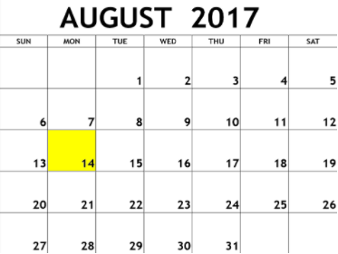
Function Description
Complete the findDay function in the editor below.
findDay has the following parameters:
- int: month
- int: day
- int: year
Returns
- string: the day of the week in capital letters
Input Format
A single line of input containing the space separated month, day and year, respectively, in format.
Constraints

Sample Input
08 05 2015
Sample Output
WEDNESDAY
Explanation
The day on August ^{th} was WEDNESDAY.
Language
Java 15
More
CODE:
import java.util.*;
import java.io.*;

public class Solution {

public static String findDay(int month, int day, int year) {
Calendar calendar = Calendar.getInstance();
calendar.set(year, month - 1, day); // month is 0-indexed in Calendar

// Get the day of the week
int dayOfWeek = calendar.get(Calendar.DAY_OF_WEEK);

// Map the integer to the day name
String[] days = {"SUNDAY", "MONDAY", "TUESDAY", "WEDNESDAY", "THURSDAY", "FRIDAY", "SATURDAY"};

return days[dayOfWeek - 1];
}

public static void main(String[] args) {
Scanner in = new Scanner(System.in);
int month = in.nextInt();
int day = in.nextInt();
int year = in.nextInt();

System.out.println(findDay(month, day, year));
}
}

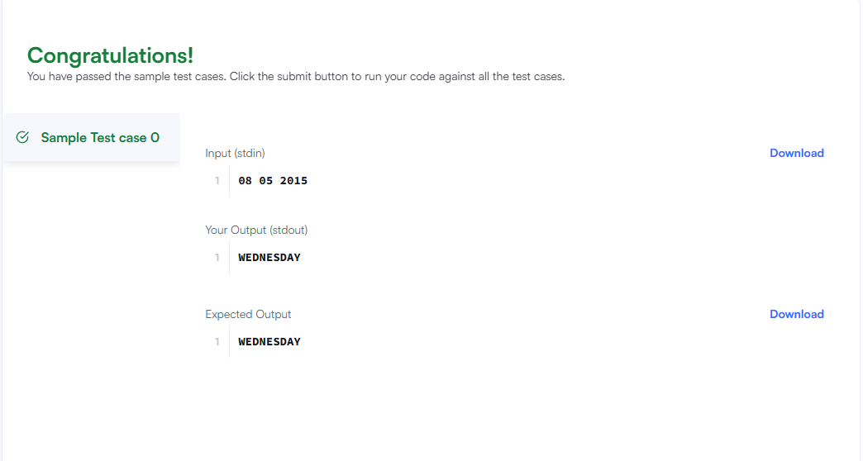

11
A Java abstract class is a class that can't be instantiated. That means you cannot create new instances of an abstract class. It works as a base for subclasses. You should learn about Java Inheritance before attempting this challenge.
Following is an example of abstract class:
abstract class Book{
String title;
abstract void setTitle(String s);
String getTitle(){
return title;
}
}
If you try to create an instance of this class like the following line you will get an error:
Book new_novel=new Book();
You have to create another class that extends the abstract class. Then you can create an instance of the new class.
Notice that setTitle method is abstract too and has no body. That means you must implement the body of that method in the child class.
In the editor, we have provided the abstract Book class and a Main class. In the Main class, we created an instance of a class called MyBook. Your task is to write just the MyBook class.
Your class mustn't be public.
Sample Input
A tale of two cities
Sample Output
The title is: A tale of two cities

CODE:
import java.util.*;
abstract class Book{
String title;
abstract void setTitle(String s);
String getTitle(){
return title;
}
}

class MyBook extends Book {
void setTitle(String s) {
title = s;
}
}

public class Main{

public static void main(String []args){
//Book new_novel=new Book(); This line prHMain.java:25: error: Book is abstract; cannot be instantiated
Scanner sc=new Scanner(System.in);
String title=sc.nextLine();
MyBook new_novel=new MyBook();
new_novel.setTitle(title);
System.out.println("The title is: "+new_novel.getTitle());
sc.close();

}
}
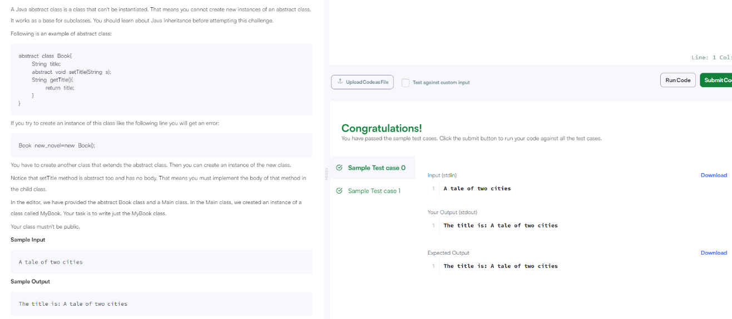

12
11. Write the following code in your editor below:
- A class named Arithmetic with a method named add that takes integers as parameters and returns an integer denoting their sum.
- A class named Adder that inherits from a superclass named Arithmetic.
Your classes should not be be .
Input Format
You are not responsible for reading any input from stdin; a locked code stub will test your submission by calling the add method on an Adder object and passing it integer parameters.
Output Format
You are not responsible for printing anything to stdout. Your add method must return the sum of its parameters.
Sample Output
The main method in the Solution class above should print the following:
My superclass is: Arithmetic
42 13 20

CODE:
import java.io.*;
import java.util.*;
import java.text.*;
import java.math.*;
import java.util.regex.*;

class Arithmetic {
public int add(int a, int b) {
return a + b;
}
}

class Adder extends Arithmetic {

}

public class Solution{
public static void main(String []args){
// Create a new Adder object
Adder a = new Adder();

// Print the name of the superclass on a new line
System.out.println("My superclass is: " + a.getClass().getSuperclass().getName());

// Print the result of 3 calls to Adder's `add(int,int)` method as 3 space-separated integers:
System.out.print(a.add(10,32) + " " + a.add(10,3) + " " + a.add(10,10) + "\n");
}
}
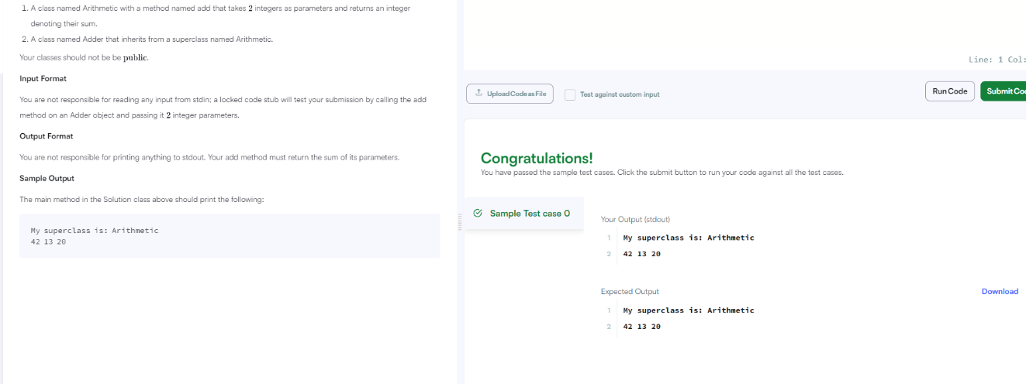

13
10. Given a double-precision number, , denoting an amount of money, use the NumberFormat class' getCurrencyInstance method to convert into the US, Indian, Chinese, and French currency formats. Then print the formatted values as follows:
US: formattedPayment
India: formattedPayment
China: formattedPayment
France: formattedPayment
where is formatted according to the appropriate Locale's currency.
Note: India does not have a built-in Locale, so you must construct one where the language is en (i.e., English).
Input Format
A single double-precision number denoting .
Constraints

Output Format
On the first line, print US: u where is formatted for US currency.
On the second line, print India: i where is formatted for Indian currency.
On the third line, print China: c where is formatted for Chinese currency.
On the fourth line, print France: f, where is formatted for French currency.
Sample Input
12324.134
Sample Output
US: $12,324.13
India: Rs.12,324.13
China: ￥12,324.13
France: 12 324,13 €
CODE:

import java.util.*;
import java.text.*;

public class Solution {

public static void main(String[] args) {
Scanner scanner = new Scanner(System.in);
double payment = scanner.nextDouble();
scanner.close();
NumberFormat us = NumberFormat.getCurrencyInstance(Locale.US);
NumberFormat china = NumberFormat.getCurrencyInstance(Locale.CHINA);
NumberFormat france = NumberFormat.getCurrencyInstance(Locale.FRANCE);

// Create Indian Locale
Locale indiaLocale = new Locale("en", "IN");
NumberFormat india = NumberFormat.getCurrencyInstance(indiaLocale);

System.out.println("US: " + us.format(payment));
System.out.println("India: " + india.format(payment));
System.out.println("China: " + china.format(payment));
System.out.println("France: " + france.format(payment));
}
}

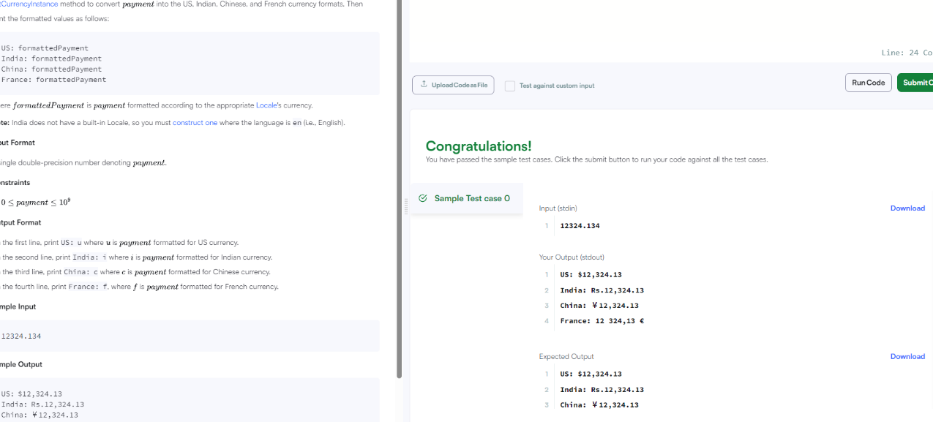

14
9. Static initialization blocks are executed when the class is loaded, and you can initialize static variables in those blocks.
It's time to test your knowledge of Static initialization blocks. You can read about it here.
You are given a class Solution with a main method. Complete the given code so that it outputs the area of a parallelogram with breadth and height . You should read the variables from the standard input.
If or , the output should be "java.lang.Exception: Breadth and height must be positive" without quotes.
Input Format
There are two lines of input. The first line contains : the breadth of the parallelogram. The next line contains : the height of the parallelogram.

Output Format
If both values are greater than zero, then the main method must output the area of the parallelogram. Otherwise, print "java.lang.Exception: Breadth and height must be positive" without quotes.
Sample input 1
1
3
Sample output 1
3
Sample input 2
-1
2
Sample output 2
java.lang.Exception: Breadth and height must be positive

CODE:
import java.io.*;
import java.util.*;
import java.text.*;
import java.math.*;
import java.util.regex.*;

public class Solution {
static int B,H;
static boolean flag=true;

static{
Scanner sc=new Scanner(System.in);
B=sc.nextInt();
H=sc.nextInt();
if(B<=0||H<=0){
flag=false;
System.out.println("java.lang.Exception: Breadth and height must be positive");
}
}

public static void main(String[] args){
if(flag){
int area=B*H;
System.out.print(area);
}

}//end of main

}//end of class

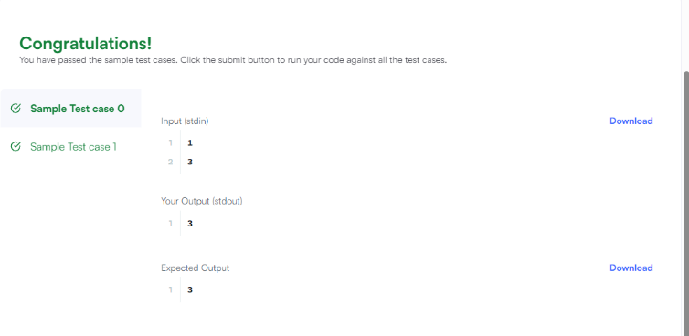

15
8. "In computing, End Of File (commonly abbreviated EOF) is a condition in a computer operating system where no more data can be read from a data source.")
The challenge here is to read lines of input until you reach EOF, then number and print all lines of content.
Hint: Java's Scanner.hasNext() method is helpful for this problem.
Input Format
Read some unknown lines of input from stdin(System.in) until you reach EOF; each line of input contains a non-empty String.
Output Format
For each line, print the line number, followed by a single space, and then the line content received as input.
Sample Input
Hello world
I am a file
Read me until end-of-file.
Sample Output
1 Hello world
2 I am a file
3 Read me until end-of-file.

CODE:
import java.util.*;
public class Solution{
public static void main(String[]args){
Scanner sc=new Scanner(System.in);
int i=1;
while(sc.hasNextLine()){
System.out.println(i+" "+sc.nextLine());
i++;
}
sc.close();
}
}
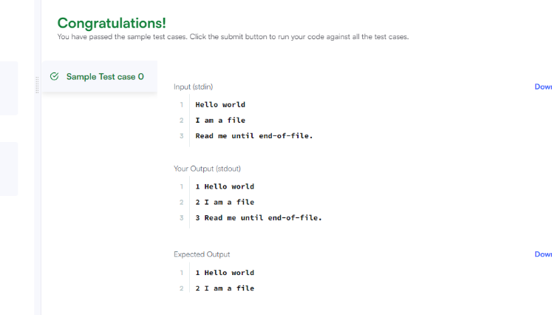

16
. Java has 8 primitive data types; char, boolean, byte, short, int, long, float, and double. For this exercise, we'll work with the primitives used to hold integer values (byte, short, int, and long):
- A byte is an 8-bit signed integer.
- A short is a 16-bit signed integer.
- An int is a 32-bit signed integer.
- A long is a 64-bit signed integer.
Given an input integer, you must determine which primitive data types are capable of properly storing that input.
To get you started, a portion of the solution is provided for you in the editor.
Input Format
The first line contains an integer, , denoting the number of test cases.
Each test case, , is comprised of a single line with an integer, , which can be arbitrarily large or small.
Output Format
For each input variable and appropriate primitive , you must determine if the given primitives are capable of storing it. If yes, then print:
n can be fitted in:
* dataType
If there is more than one appropriate data type, print each one on its own line and order them by size (i.e.: ).
If the number cannot be stored in one of the four aforementioned primitives, print the line:
n can't be fitted anywhere.
Sample Input
5
-150
150000
1500000000
213333333333333333333333333333333333
-100000000000000
Sample Output
-150 can be fitted in:
* short
* int
* long
150000 can be fitted in:
* int
* long
1500000000 can be fitted in:
* int
* long
213333333333333333333333333333333333 can't be fitted anywhere.
-100000000000000 can be fitted in:
* long

CODE:
import java.util.Scanner;
public class Solution{
public static void main(String[] args){
Scanner sc=new Scanner(System.in);
int t=sc.nextInt();
for(int i=0;i<t;i++){
try{
long x=sc.nextLong();
System.out.println(x+" can be fitted in:");
if(x>=-128&&x<=127)
System.out.println("* byte");
if(x>=-32768&&x<=32767)
System.out.println("* short");
if(x>=-2147483648L&&x<=2147483647L)
System.out.println("* int");
System.out.println("* long");
}
catch(Exception e){
System.out.println(sc.next()+" can't be fitted anywhere.");
}
}
sc.close();
}
}

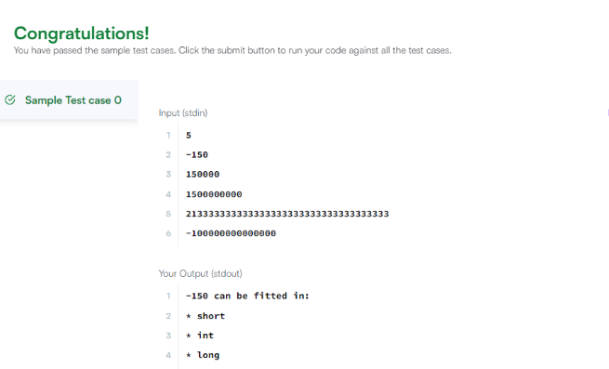
17
When a subclass inherits from a superclass, it also inherits its methods; however, it can also override the superclass methods (as well as declare and implement new ones). Consider the following Sports class:
Java code
class Sports {
String getName() {
return "Generic Sports";
}
void getNumberOfTeamMembers() {
System.out.println("Each team has n players in " + getName());
}
}
class Soccer extends Sports {
@Override
String getName() {
return "Soccer Class";
}
@Override
void getNumberOfTeamMembers() {
System.out.println("Each team has 11 players in " + getName());
}
}
public class Solution {
public static void main(String[] args) {
Sports c1 = new Sports();
Soccer c2 = new Soccer();
System.out.println(c1.getName());
c1.getNumberOfTeamMembers();
System.out.println(c2.getName());
c2.getNumberOfTeamMembers();
}
}
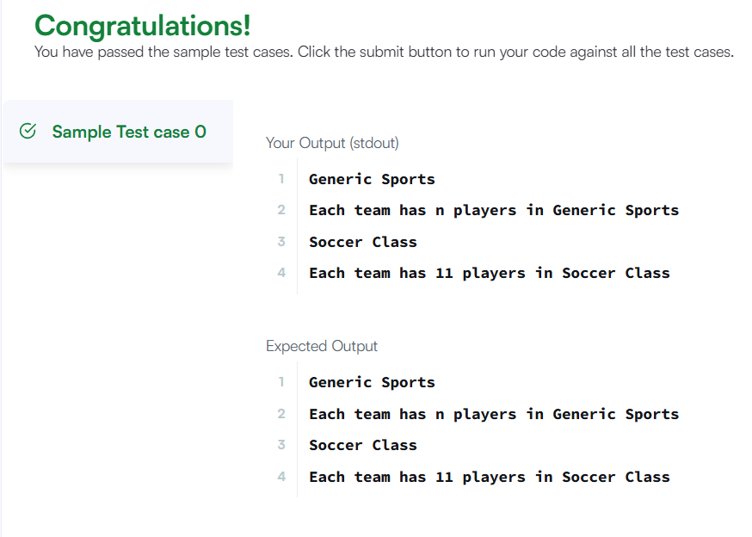

18
A Java interface can only contain method signatures and fields. The interface can be used to achieve polymorphism. In this problem, you will practice your knowledge on interfaces.
You are given an interface AdvancedArithmetic which contains a method signature int divisor_sum(int n). You need to write a class called MyCalculator which implements the interface.
divisorSum function just takes an integer as input and return the sum of all its divisors. For example divisors of 6 are 1, 2, 3 and 6, so divisor_sum should return 12. The value of n will be at most 1000.
Read the partially completed code in the editor and complete it. You just need to write the MyCalculator class only. Your class shouldn't be public.
Java code
import java.util.*;
interface AdvancedArithmetic {
int divisor_sum(int n);
}
class MyCalculator implements AdvancedArithmetic {

@Override
public int divisor_sum(int n) {
int sum = 0;
for (int i = 1; i <= n; i++) {
if (n % i == 0) {
sum += i;
}
}
return sum;
}
}
public class Solution {
public static void main(String[] args) {
Scanner sc = new Scanner(System.in);
int n = sc.nextInt();
MyCalculator my_calculator = new MyCalculator();

System.out.println("I implemented: AdvancedArithmetic");
System.out.println(my_calculator.divisor_sum(n));

sc.close();
}
}
